# Bias and Variance: Formal and Layman Explanations

## Formal Explanation

### 1. Three Kinds of Error

Inherent Error: This is the error that is unavoidable in any modeling process. It is due to the inherent noise present in the data and the limitations of the model in capturing every aspect of the underlying real-world process. Even with the best model, some level of error is inevitable due to factors beyond our control.

Bias: This refers to the error introduced by the model's assumptions in simplifying the problem. High bias can cause the model to miss important patterns and relationships in the data, leading to underfitting. A model with high bias pays less attention to the training data and does not generalize well.

Variance: This is the error introduced due to the model's sensitivity to small fluctuations in the training data. High variance can lead to overfitting, where the model captures noise in the training data rather than the underlying pattern. A model with high variance is too complex and performs well on training data but poorly on unseen data.

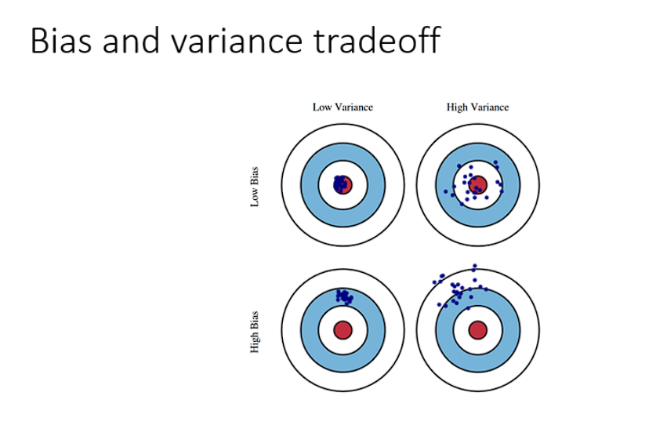

### 2. Bias and Variance Tradeoff

The bias-variance tradeoff is a fundamental concept in machine learning. It represents the balance between two sources of error that affect the performance of a model.

Low Bias, Low Variance: This is the ideal scenario where the model makes accurate predictions with minimal error, capturing the underlying pattern without being too sensitive to fluctuations.

High Bias, Low Variance: The model is overly simplified and fails to capture the underlying patterns in the data, leading to systematic errors (underfitting).

Low Bias, High Variance: The model is overly complex and fits the training data too closely, capturing noise as if it were a pattern (overfitting).

High Bias, High Variance: The worst-case scenario where the model is both too simple and too sensitive, resulting in poor generalization and high error rates on new data.

### 

### 3. Bias/Variance Tradeoffs

The table provided shows the relationship between bias, variance, and the resulting error on training and development sets using a cat classification example.

High Variance (Low Bias): The model performs well on the training set (low error) but poorly on the development set (high error), indicating overfitting.

High Bias (Low Variance): The model performs poorly on both the training and development sets, indicating underfitting.

High Bias, High Variance: The model has a poor performance on both sets, showing both underfitting and overfitting issues.

Low Bias, Low Variance: The desired outcome where the model performs well on both sets, indicating it is well-balanced and generalizes well to new data.

## Layman Explanation

### 1. Three Kinds of Error

Inherent Error: Think of this as the "unavoidable mistakes." No matter how good your model is, some errors are just part of the process because of unpredictable factors or noise.

Bias: Imagine you're trying to guess the average height of people, but you only look at children. You'll likely underestimate the true average height. This mistake happens because you're simplifying the problem too much. That's what bias is—it's the error from using a model that is too simple and doesn't capture the complexity of the real world.

Variance: Now, imagine you look at only a small group of people and make a model based on them. If you use this model on a different group, you might get very different results. This happens because your model is too sensitive to the specific details of your initial group, and that's what variance is—it's the error from making a model that's too complex and too tuned to the specific data you used to build it.

### 2. Bias and Variance Tradeoff

Balancing bias and variance is like trying to hit a target with darts.

Low Bias, Low Variance: You're consistently hitting close to the center. Your model is accurate and reliable.

High Bias, Low Variance: You're missing the target, but all your darts land in about the same wrong spot. Your model is too simple and ignores important details.

Low Bias, High Variance: You hit the target sometimes, but your darts are scattered all over the place. Your model is too complicated and gets confused by random details.

High Bias, High Variance: You're not hitting the target at all, and your darts are all over the place. Your model is both too simple and too complicated in the wrong ways.

### 3. Bias/Variance Tradeoffs

Imagine you're training a cat recognition system. If you make your system too simple, it will get most things wrong (high bias). If you make it too complicated, it might think every shadow or random shape is a cat (high variance).

High Variance (Low Bias): Your system is great at recognizing the cats in the training photos but fails with new photos because it's too tailored to the training set.

High Bias (Low Variance): Your system doesn't recognize many cats, even in the training set, because it's too simple.

High Bias, High Variance: Your system doesn't recognize many cats in either the training or new photos because it's both too simple and too confused.

Low Bias, Low Variance: Your system correctly identifies cats in both the training photos and new ones. This is what you aim for.